**DAILY ONLINE ACTIVITIES SUMMARY**

|  |  |  |  |  |  |  |  |  |
| --- | --- | --- | --- | --- | --- | --- | --- | --- |
| **Date:** | **16/06/2020** | | | | | **Name:** | **V ANJANA PAI** | |
| **Sem & Sec** | **IV sem & B section** | | | | | **USN:** | **4AL18CS094** | |
| **Online Test Summary** | | | | | | | | |
| **Subject** | | **COMPLEX ANALYSIS, PROBABILITY AND STATISTICAL METHODS** | | | | | | |
| **Max. Marks** | | **30** | | **Score** | | | **20** | |
| **Certification Course Summary** | | | | | | | | |
| **Course** | **Introduction to Ethical Hacking** | | | | | | | |
| **Certificate Provider** | | | **Great learning academy** | | **Duration** | | | **4.5 hours** |
| **Coding Challenges** | | | | | | | | |
| **Problem Statement1:** Write a Python program to check whether a given a binary tree is a valid binary search tree (BST) or not? | | | | | | | | |
| **Status: Executed** | | | | | | | | |
| **Uploaded the report in GitHub** | | | | | **YES** | | | |
| **If yes Repository name** | | | | | **lockdown-coding** | | | |
| **Uploaded the report in slack** | | | | | **YES** | | | |

Online Test Summary:18MAT41 test was scheduled from 3:00pm t0 3:40pm. The portion for the IA was 1st module there were 15 questions and the time assigned was 40 minutes the questions were mcq type.

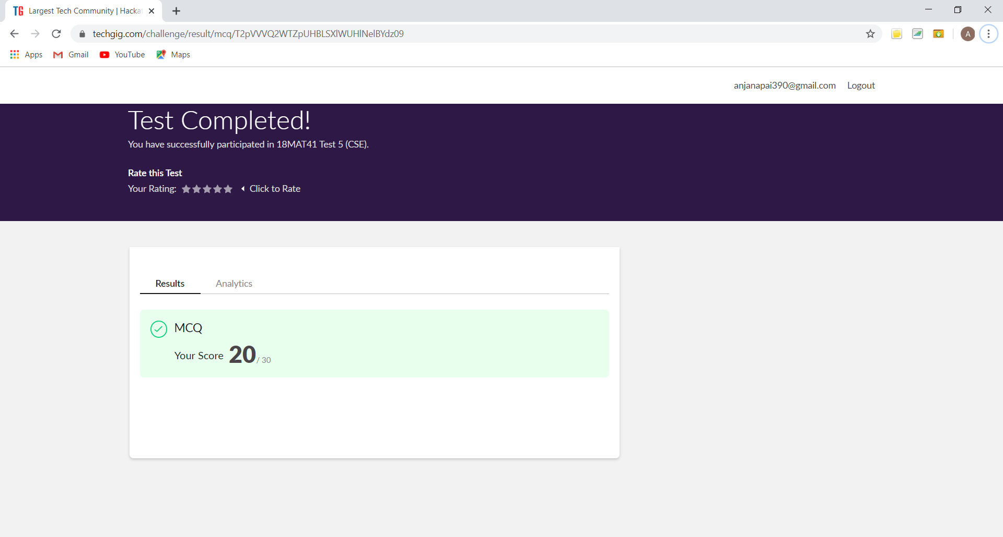

This is the completion of test and marks obtained for 18MAT41.

Online Certification Course Summary: Today I took up the Quiz of Introduction to Ethical Hacking Course and obtained the certificate for completion of the course from Great Learning Academy.

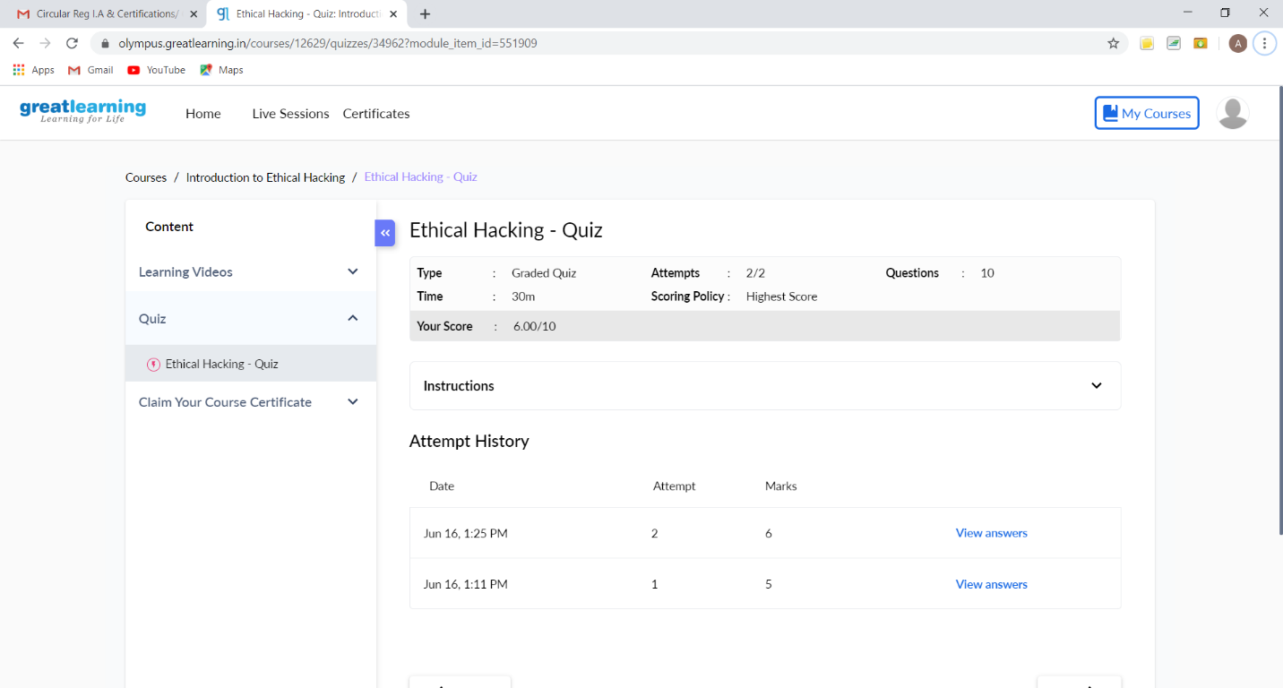

This is the snapshot of Quiz taken.

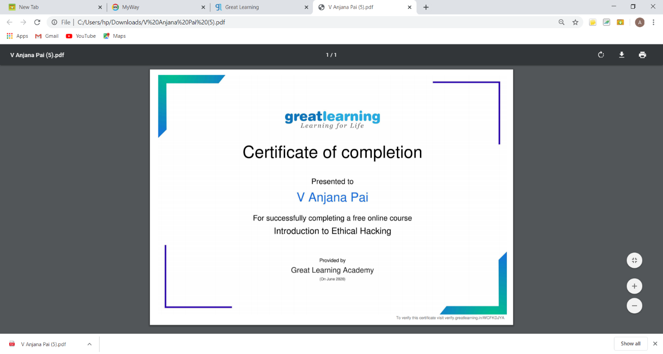

This is the snapshot of certificate obtained for completing the course.

Online Coding Summary: **Today I had received one program from prof. Vasudev CSE Dept. The program is mentioned above in the coding challenges(pg.01). I have also uploaded it to my GitHub repository.**

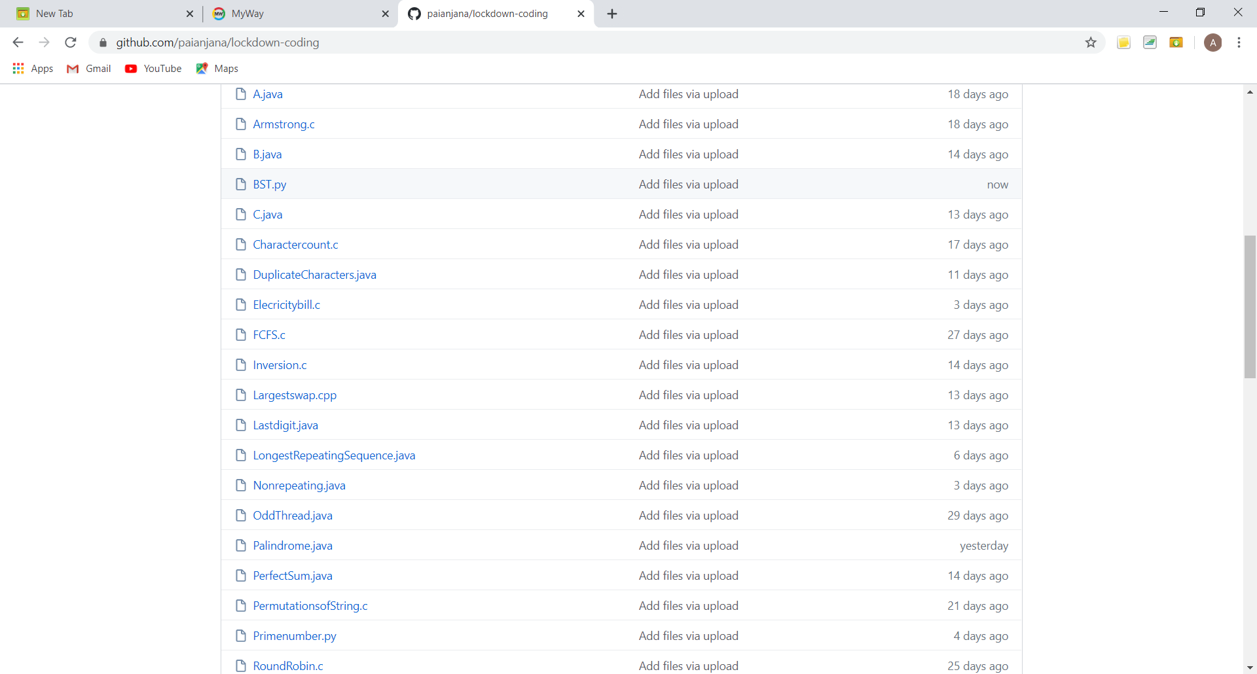

**This is the snap shot of my GitHub repository** where I have uploaded the code. File name is BST.py